AI-Augmented Backend Development Project :

TITLE :Ai FitTrack

Project Description

In a Single Paragraph
Ai FitTrack is an AI-Augmented backend Web Application developed using the (MongoDB, Express.js,Node.js) integrated with Artificial Intelligence capabilities such as Large Language Models (LLMs), Semantic Search, Vector Search, and Intelligent Recommendations. The system enables users to interact with data through natural language, receive AI-generated insights, perform semantic searches, upload and analyze documents, and automate decision-making processes. By combining traditional backend development with modern AI technologies, the platform delivers an intelligent, scalable, and user-friendly experience that improves productivity, accessibility, and operational efficiency.

Scenario
Write the Scenario section by describing the real-world problem or situation that your application is designed to solve.
Explain the scenario in 2–3 paragraphs and cover the following points:
Identify the Problem
Explain a real-world problem faced by users or organizations in the selected domain. Mention the limitations of traditional systems or manual processes.
- Explain the Need for AI
Describe why traditional approaches are not sufficient and how Artificial Intelligence can improve the existing process.
- Describe the Proposed Solution
Explain how your Ai FitTrack addresses the identified problem using AI capabilities such as:
  - AI Chatbot
  - Content Generation
  - Question Answering
  - Semantic Search
  - Vector Search
  - Intelligent Recommendations
  - Document Analysis
  - AI-powered Insights

Structure :
Problem:
Many people struggle to maintain a healthy fitness routine because they do not have proper guidance, personalized workout plans, or a simple way to track their progress. Beginners may also find it difficult to choose suitable exercises, monitor their daily activity, and maintain consistency.

AI Solution:
AI FitTrack is an AI-powered fitness application that provides personalized workout and fitness guidance based on the user’s goals, activity level, and progress. AI features can include personalized workout recommendations, exercise guidance, activity and progress tracking, smart reminders, and AI-based analysis of fitness performance.

Impact:
The application will benefit students, beginners, fitness enthusiasts, and people who want to improve their daily physical activity. AI FitTrack can make fitness more personalized, organized, and easier to follow by helping users track their progress and stay consistent with their fitness goals.

System Requirements :
To ensure smooth development, deployment, and usage of the AI-Fittrack AI-Augmented Backend Application, certain system prerequisites must be met.

1. Software Requirements

Operating System
- Windows 10/11
- macOS
- Linux

Node.js (v18 or above)
Provides a runtime environment for frontend and backend development.

npm (v9 or above)
Package manager used for dependency installation.

Express.js
Backend framework used for API development.

MongoDB Community Server / MongoDB Atlas
NoSQL database used to store:
- User Information
- Chat History
- Documents
- Embeddings
- AI Interactions
- Application Data

MongoDB Atlas Search
Provides full-text search functionality.

MongoDB Atlas Vector Search
Enables semantic search using vector embeddings.

AI Service Provider
- OpenAI API
- Gemini API
- Claude API
- Azure OpenAI (Optional) …etc

LangChain / AI SDK
Used for orchestration of AI workflows.

Browser
- Google Chrome
- Mozilla Firefox

Postman
API Testing

Visual Studio Code
Development Environment

Git & GitHub
Version Control

2. Hardware Requirements

Processor
Intel Core i5 (8th Gen+) / AMD Ryzen 5+

RAM
Minimum 8 GB
Recommended 16 GB

Storage
Minimum 5 GB Free Space

Internet Connection
Required for AI API communication

Display
1366 × 768 or above

Project Architecture

Technical Architecture :
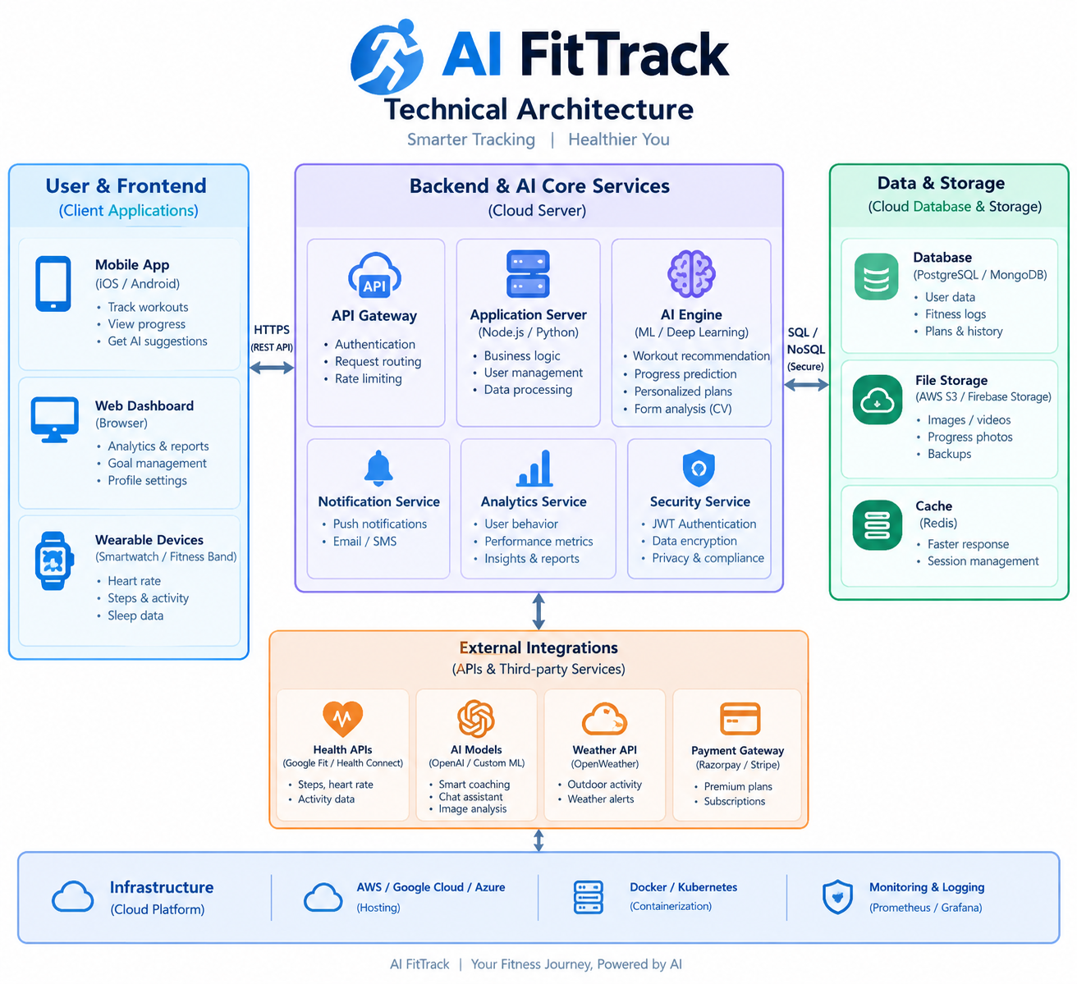

Backend Layer
- Node.js
- Express.js
- JWT Authentication
- REST APIs

Database Layer
- MongoDB
- Atlas Search
- Atlas Vector Search

AI Layer
- LLM APIs
- Embedding Models
- RAG Pipeline
- Prompt Engineering

Storage Layer
- MongoDB Collections
- File Upload Storage

Security Layer
- JWT Authentication
- Protected Routes
- Input Validation
- Role-Based Access Control

ER Diagram
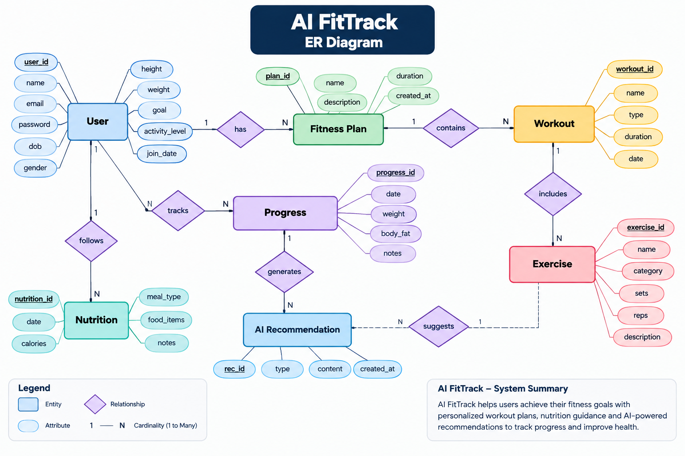

Collections

Users
- _id
- name
- email
- password
- role

Documents
- _id
- title
- content
- uploadedBy
- createdAt

Embeddings
- _id
- documentId
- vectorData

Chats
- _id
- userId
- prompt
- response
- timestamp

ActivityLogs
- _id
- userId
- activity
- createdAt

ER Diagram Explanation

The ER Diagram shows how the data in the AI FitTrack app is connected.
- User – Stores user details like name, age, height, weight, and goal.
- Fitness Plan – Stores the user's fitness plan.
- Workout – Stores workout details such as type and duration.
- Exercise – Stores exercises, sets, and repetitions.
- Progress – Tracks weight and fitness progress.
- Nutrition – Stores food and calorie details.
- AI Recommendation – Gives personalized fitness suggestions using AI.

Features

Core Backend Features
- User Registration
- User Login
- JWT Authentication
- Protected Routes
- Middleware
- CRUD API
- File Upload
- Role-Based Access Control

AI Features
- AI Chat Assistant
- Semantic Search
- Vector Search
- Document Question Answering
- Text Summarization
- Content Generator
- RAG (Retrieval Augmented Generation)
- Intelligent Insights
- Natural Language Queries

Roles and Responsibilities

Admin
- Manage Users
- Manage Documents
- Monitor AI Usage
- View Analytics
- Configure System

User
- Register/Login
- Upload Documents
- Ask Questions
- Search Content
- View AI Recommendations
- Manage Personal Data

User Flow
- User Registration
- User Login
- JWT Authentication
- Dashboard Access
- Upload Documents
- Generate Embeddings
- Store Vectors in MongoDB
- User Query Submission
- Semantic Search Execution
- AI Response Generation
- Display Results
- Store Chat History

MVC Pattern
The backend follows the MVC (Model-View-Controller) architecture.

Model Layer
Responsible for:
- User Schema
- Chat Schema
- Document Schema
- Embedding Schema
- Activity Schema
Implemented using Mongoose.

Controller Layer
Responsible for:
- Authentication Logic
- AI API Integration
- Document Processing
- Embedding Generation
- Search Operations
- CRUD Operations

View Layer (Routes)
Defines REST API endpoints:

Authentication Routes
- Register
- Login
- Logout

AI Routes
- Chat
- Summarization
- Semantic Search

Document Routes
- Upload
- View
- Delete

User Routes
- Profile
- Dashboard

Advantages of MVC
- Separation of Concerns
- Better Maintainability
- Easy Scalability
- Reusable Components
- Team Collaboration
- Easier Testing

Project Setup and Configuration

Project Structure
Create Project Folder
Inside Project Folder:

Server Folder
Backend Application

Server Setup
mkdir server

cd server

npm init -y
Create:
server.js

models/
controllers/
routes/
middlewares/
config/
services/
utils/


Install Backend Packages
npm install express mongoose cors dotenv bcryptjs jsonwebtoken

npm install openai

npm install multer

npm install nodemon --save-dev


Backend Development
Include:
- Authentication APIs
- JWT Implementation
- AI Service Integration
- Vector Search APIs
- CRUD APIs
- Document Upload APIs
- Chat APIs
Note:
Proper explanation must be provided for every AI API consumed, including:
- Purpose:
AI FitTrack is an AI-based fitness application designed to help users track their daily fitness activities, exercise, food habits, and progress. It uses AI to analyze the user's information and provide personalized fitness suggestions and recommendations.
- Request Structure:
The application collects necessary user information such as age, height, weight, activity level, fitness goals, exercise details, and food habits. This information is sent to the AI system in a structured format so that it can analyze the user's fitness requirements accurately.
- Response Structure:
After analyzing the user's information, the AI system provides a personalized response. It may include recommended exercises, daily activity suggestions, nutrition guidance, progress information, and other fitness recommendations based on the user's goals.
- Cost Considerations:
AI FitTrack should use AI services efficiently to control operational costs. The application can reduce costs by sending only necessary data, avoiding unnecessary AI requests, using suitable AI models, and monitoring API usage regularly.
- Security Practices:
AI FitTrack must protect users' personal and fitness information. Data should be securely transmitted and stored using encryption. Authentication and authorization should be implemented to prevent unauthorized access, and API keys and passwords must be stored securely. Only necessary user information should be collected and protected.

Database Development
Include:
- MongoDB Collections
- Relationships
- Atlas Search Index
- Vector Search Index
- Sample Documents
Provide screenshots and explanation.

Project Execution

Step 1: Backend
cd server

npm install


Step 2: Configure Environment Variables
Create .env
PORT=8000

MONGO_URI=mongodb://localhost:27017/ai_augmented_db

JWT_SECRET=your_secret_key

OPENAI_API_KEY=your_api_key


Step 3: Run Backend
nodemon server.js
Backend URL:
http://localhost:8000


Output with Explanation
API Testing: AI FitTrack uses API testing to verify that the application communicates correctly with the backend, database, AI services, and other external services. It helps ensure that user data, fitness information, and recommendations are transferred accurately and securely.
LLM Integration: AI FitTrack integrates a Large Language Model (LLM) to understand user questions and provide personalized fitness, nutrition, and wellness guidance. The LLM can analyze user inputs and generate simple, understandable responses.

AI Chat Interface: The application provides an AI-powered chat interface where users can ask questions about workouts, diet, fitness goals, and daily activities. The chatbot provides interactive responses based on the user's requirements.

Document Upload: Users can upload documents such as fitness reports, diet plans, or health-related files. AI FitTrack can process the uploaded information and use relevant details to provide personalized suggestions.

Search Results: The search feature allows users to find relevant fitness, exercise, nutrition, and wellness information. AI can organize and present useful search results based on the user's query.

Recommendation Engine: The recommendation engine analyzes user preferences, goals, activity information, and available data to provide personalized workout, nutrition, and fitness recommendations.

Demo Video Link
Add Demo Video URL

Source Code Drive Link
Add GitHub Repository or Drive Link

Mandatory Functionalities
- MVC Architecture
- JWT Authentication
- Semantic Search
- MongoDB Atlas Search
- MongoDB Atlas Vector Search
- Prompt Engineering
- AI API Integration
- Role-Based Access Control

